**Anisha Jain**

**Self-Work Report**

**Week 1**

**Status**

Implemented work

* Discussed the attributes to be used for user input.
* Read about how to implement react js forms.
* Created a single form frontend using React Js.
* Read about REST API.

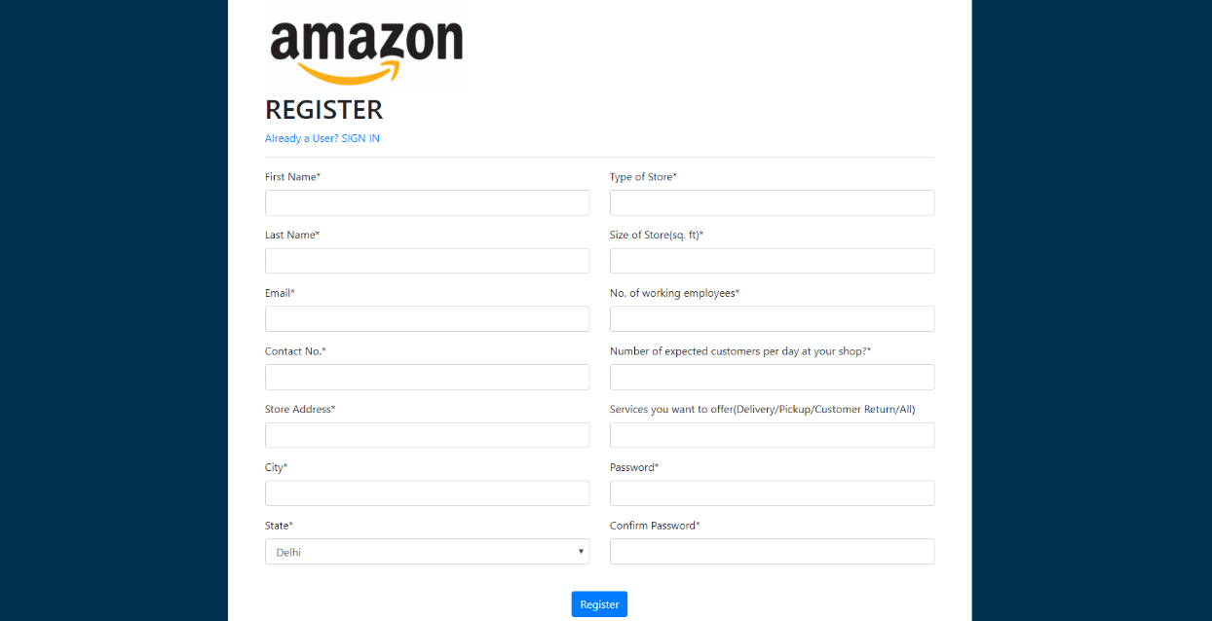Single page frontend

In Progress

* Connection of frontend with backend for getting an end-to-end workflow

**Week 2**

* As discussed converted the single page frontend to multipage frontend.
* Validation of multipage form.
* Read about various classification algorithms like logistic regression, Random forest, xgboost.
* Read about google maps API.
* Discussed upon and finalized some key parameters to be used for prediction.

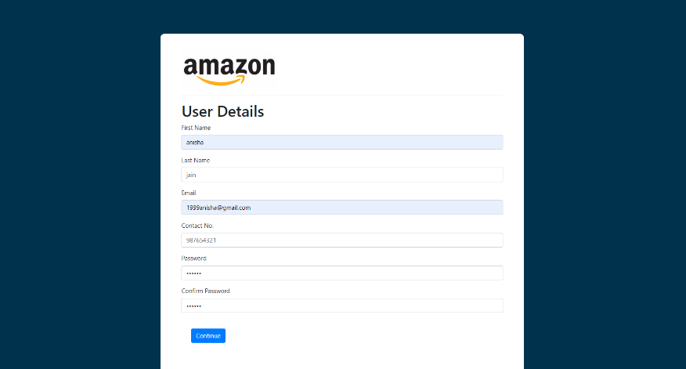

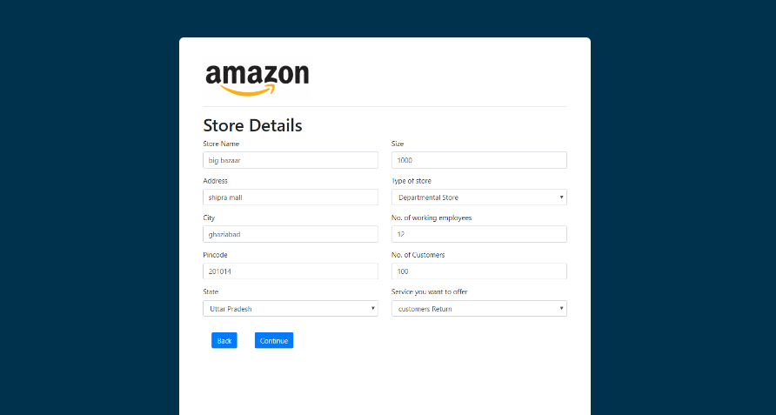

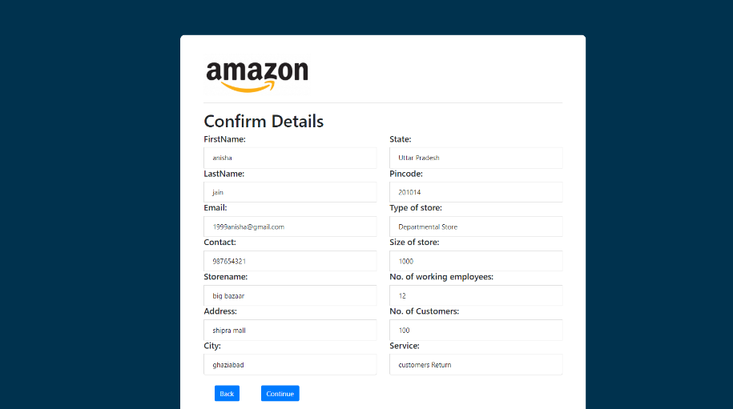

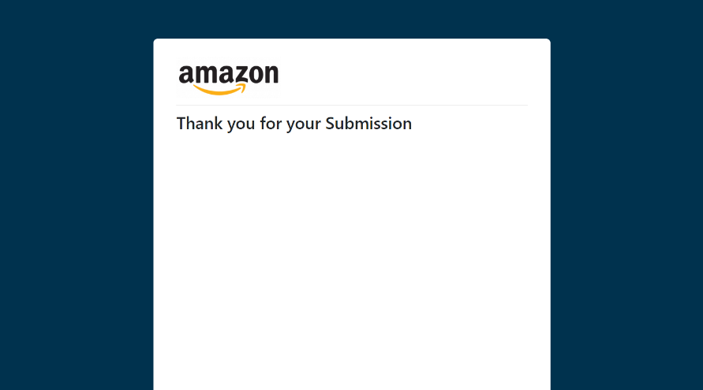

* Designed LLD diagram of our project.

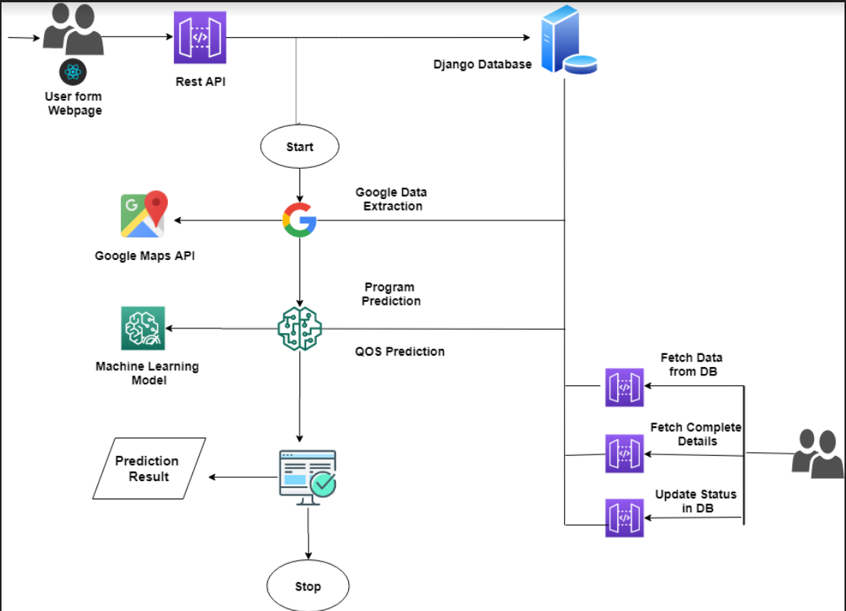

**Week 3**

* Created a Login Page.
* Read about Routing for switching between Register and Login.
* Implemented Routing between Register and login.

